**Unit 1 Assignment – Kickstart My Chart**

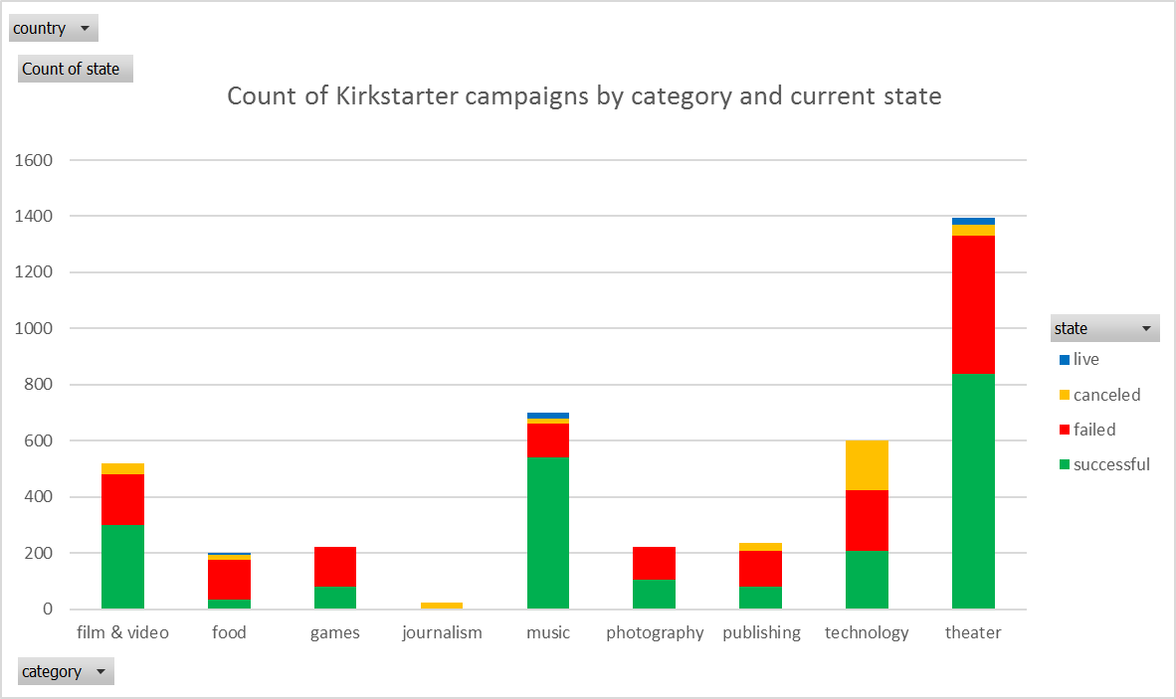

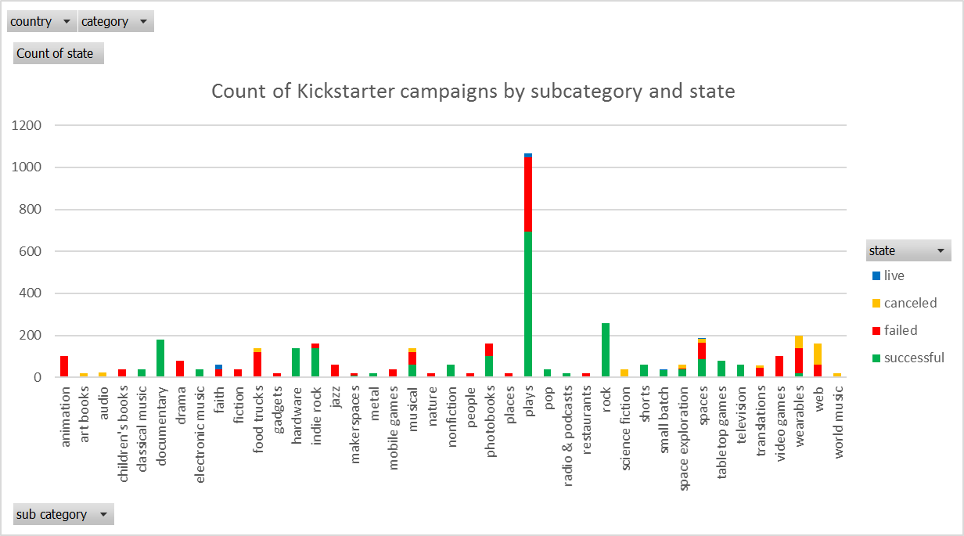

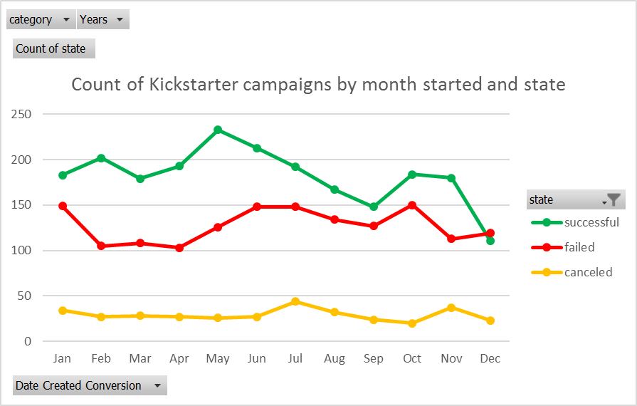

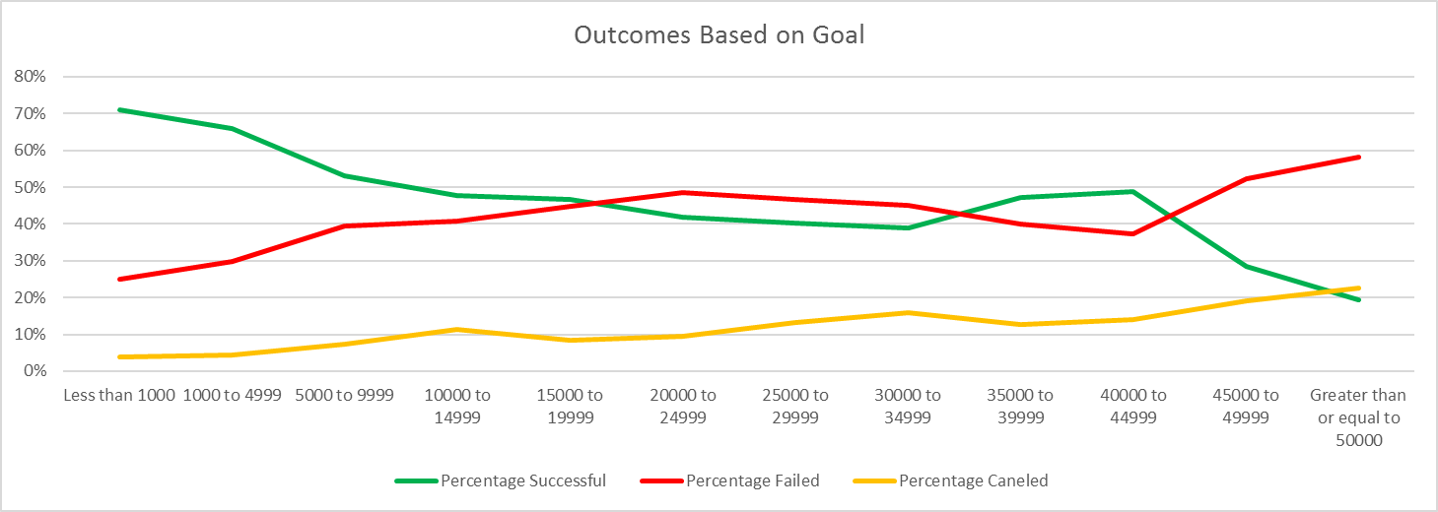

**Conclusions**

1. The category theater has the most overall, successful and failed campaigns

2. The majority of Kickstarter campaigns are successful

3. Overall, a higher number of successful Kickstarter campaigns were started in May than any other month

**Limitations**

1. There are only nine categories represented

2. The sample may not be representative, as our successful rate is 53% and in the homework details it states that only one third have made it through the funding process with a positive outcome

**Additional charts and graphs**

1. How long the campaign was open and percent funded

2. The count of backers and state

3. The count of backers and the category and or subcategory

we could use the average or create categories for number of backers, 0-100, 101-200…